Food & drink

- Which cheese is traditionally used for pizzas?

- Stollen is the traditional fruit cake of which country?

- ‘Black Krim’, ‘Green Zebra’ and ‘Yellow Pear’ are all varieties of which salad ingredient?

- Mocha is a coffee usually flavored with which substance?

- In Italy, what is a Mortadella?

- Enchiladas originated in which country?

- Goulash is a national dish of which European country?

Music

- Who sang the song ‘Heart of Glass’ released in the late seventies.

- Complete the title of this 1996 UK single chart hit from rapper Mark Morrisson - ‘Return of the …’

- Which US rapper had 1998 hits with ‘Gettin’ Jiggy Wit It’, ‘Just The Two Of Us’ and ‘Miami’?

- Which group released 'We Built This City' in 1985?

- Which 1988 Michael Jackson hit begins 'I'm gonna make a change, / For once I'm my life'?

- Name the group based on the band members: Carl Barat, Pete Doherty, John Hassell, Gary Powell

- Where did rap superstar Eminem grow up?

Geography

- Where in the UK are the famous cheese caves, Cheddar Gorge?

- Where in Italy is the Bridge of Sighs?

- Where in the United States would you find The Lincoln Memorial?

- What is the name of the longest mountain range in South America?

- The Clifton Suspension Bridge is most closely associated with which British city?

- Which type of bird appears on the national flag of Mexico?

History

- What year did World War 2 start?

- When was the famous Battle of Heisting’s fought?

- Who invented electricity?

- Which famous nurse managed and trained nurses during the Crimean War?

- 'We Shall Fight on the Beaches' was a famously quoted by who?

Film & TV
- Who directed the films E.T, the color purple and Indiana jones and the temple of doom?

- Who plays the Genie in the 2019 adaptation of Aladdin?

- Which actor played the lead in ‘Romeo and Juliet’, ‘catch me if you can’, ‘the beach’ and ‘shutter island’

- Which famous rapper starred in the film 8 mile in 2002?

- Who was the highest paid US actor in 2019

Picture
Answers
1 – Mozzarella, 2 – Germany, 3 - Tomato, 4 – Chocolate, 5 – Sausage, 6 - Mexico , 7– Hungary 8 -Blondie, 9 – Mack, 10 – Will Smith, 11– Starship, 12 – Man in the Mirror, 13 - Libertines, 14 –Detroit, 15 – Somerset , 16 – Venice, 17 – Washington DC, 18 - Andes, 19 –Bristol , 20 – Eagle, 21 – 1939, 22 – 1066, 23 – Benjamin Franklin , 24 – Florence Nightingale 25 - Winston Churchill 26 - Steven Spielberg 27 -Will Smith, 28 Leonardo Di Caprio, 29 – Eminem, 30 - Dwayne Johnson (AKA the rock),
A – Polar bear, B - Toucan, C - Chimpanzee, D – Goat, E – Giraffe, F – Frog, G - Tiger, H - Pig, I - Owl, J - Elephant,

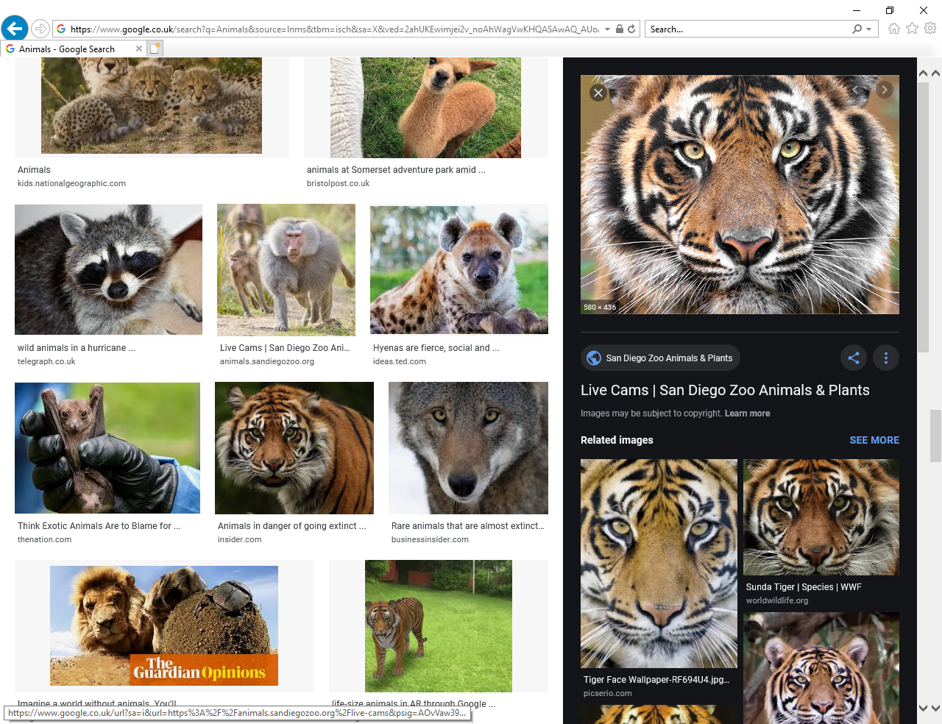  G | H  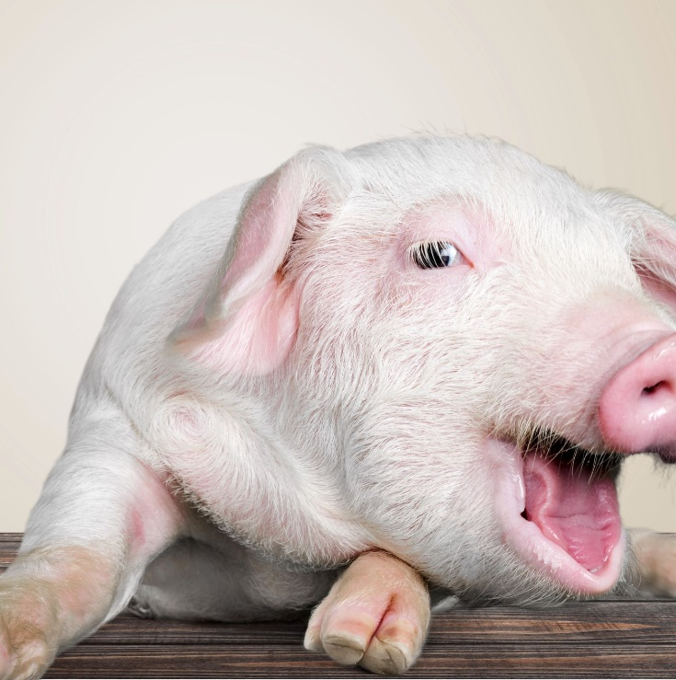
I  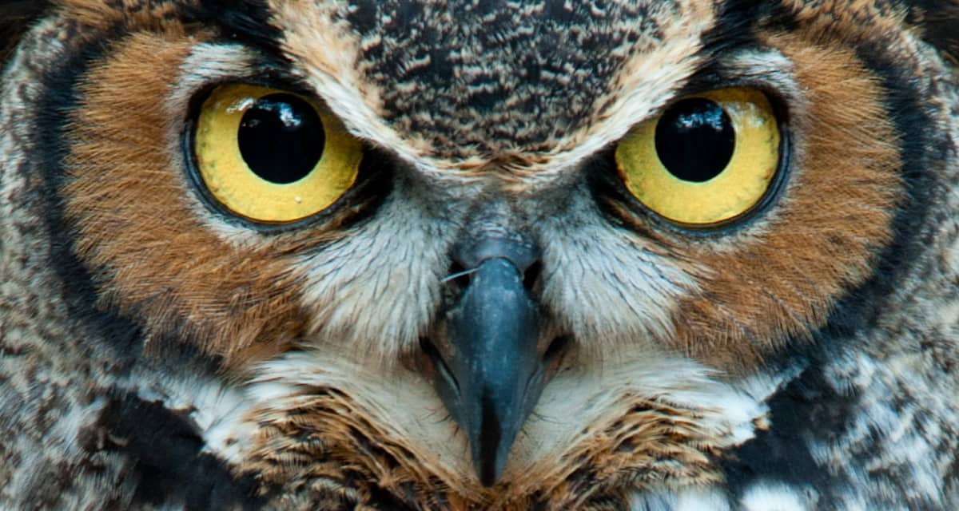 | 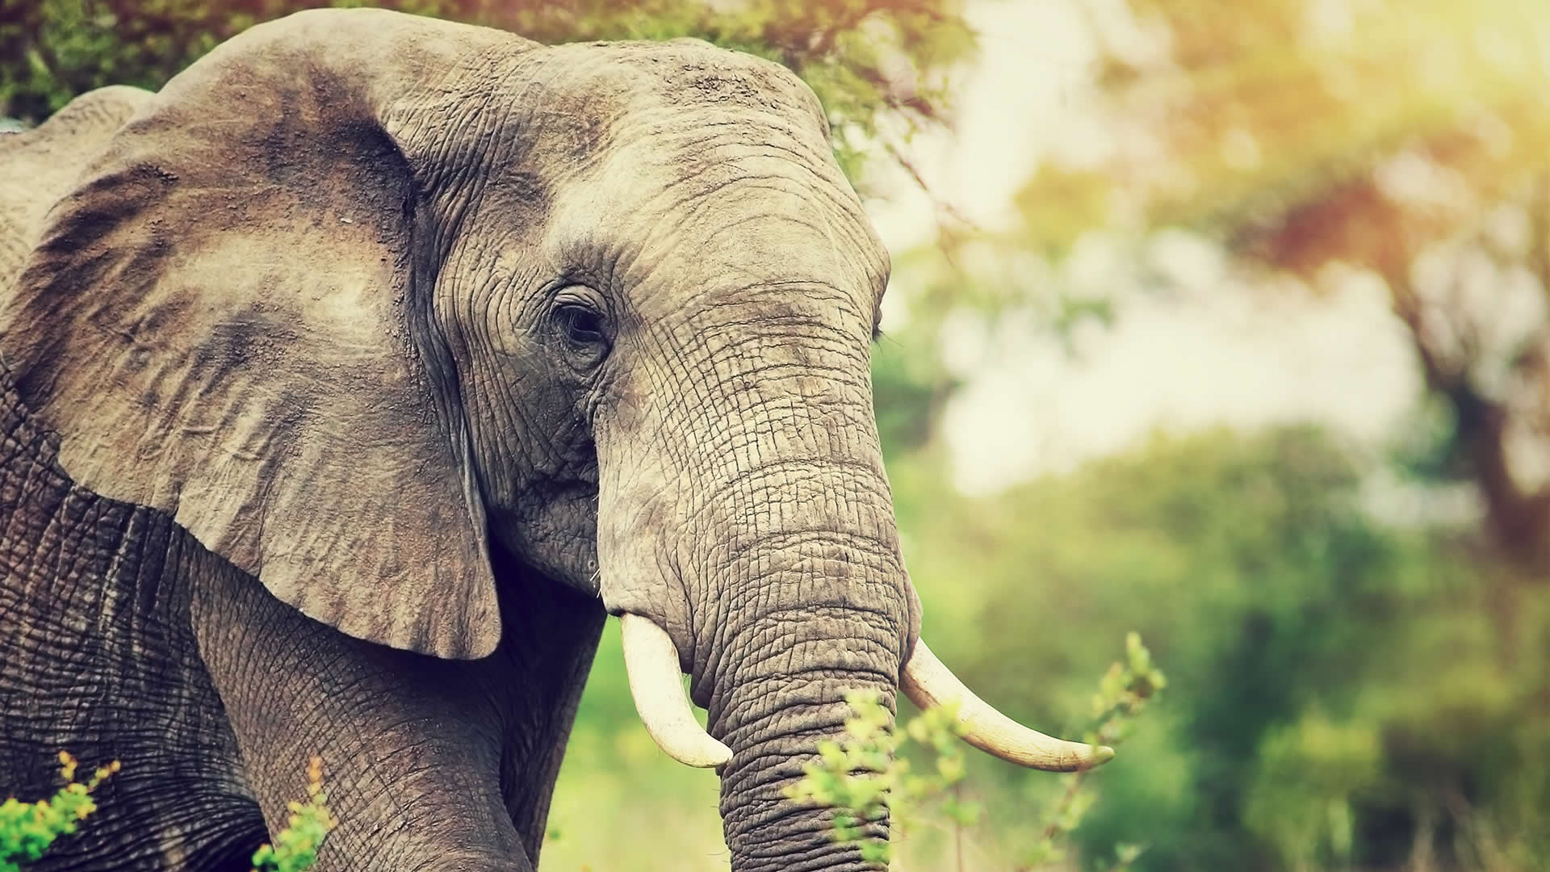  J
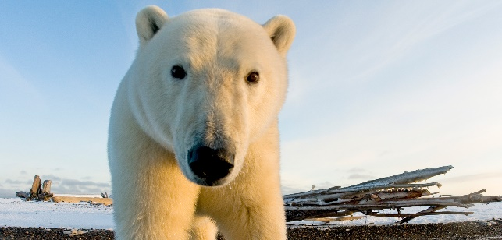  A | 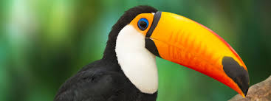  B
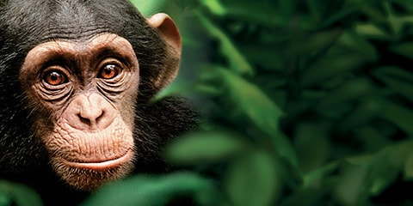  C | 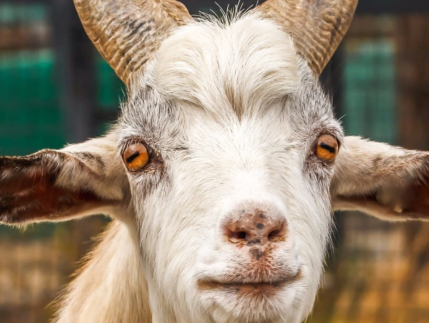  D
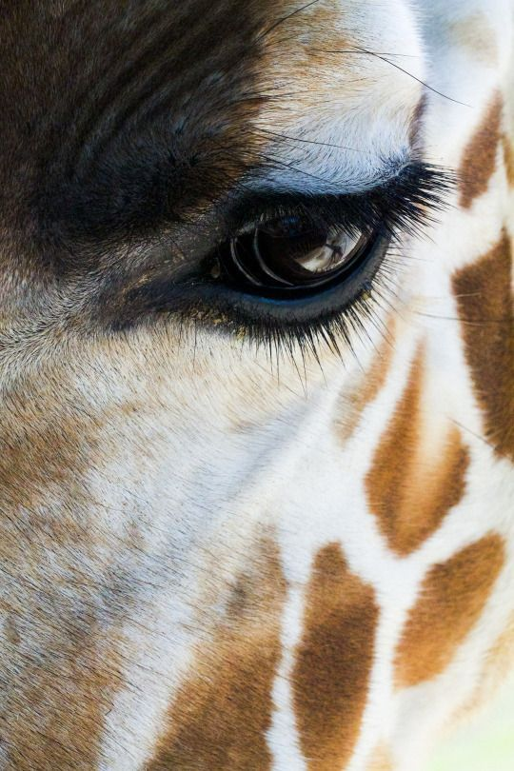  E | 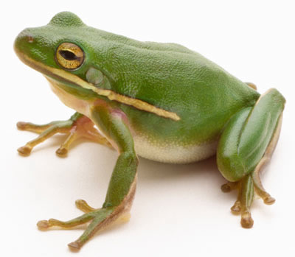  F

