Food & drink

- What type of food is Basmati?

- What is the primary herb used to make Pesto?

- Moussaka is made with layers of mince and what vegetable?

- What fruit are prunes dried from?

- Caldo verde is a traditional Soup dish from which Country?

Music

- How old was Avril Lavigne when she signed her first recording contract?

- Michael Jackson was known as the King of Pop but who has been known as the Queen of Pop?

- R Kelly’s song ‘I believe I can fly’ was the sound track to what movie?

- What is the name of Nirvana’s 1989 debut album?

- Pop star Kesha calls her fans Animals but what does Lady GaGa name her Fans?

Geography

- What is the largest Lake in Africa?

- Where would you find st Peters Basilica?

- What is the name of the mountain in Wales?

- What is the tallest building in the UK?

- 30 St Mary Axe is a London sky scraper more commonly known as what?

History

- What Year did the Titanic Sink?

- The fall of the Berlin wall was in November of what year?

- What year was the 9/11 terrorist attacks?

- How the Bubonic Plague was most commonly thought to have spread?

- Where was the great fire of London thought to have started?

Film & TV

- Name the leading lady in the following films ‘Domino’, ‘Finding a friend for the end of the world’, ‘pride and predigest’ and ‘The Duchess’

- Mean Streets, Taxi Driver, and Goodfellas where all directed by who?

- Who directed the film Pulp Fiction?

- Who is the voice of woody in Toy story?

- Who holds the record for the most Oscars for acting, having won four Academy Awards across their career and earned a total of 12 nominations?

Science

- Which planet has the most moons?

- In the periodic table, what's the symbol for zinc?

- Percy Spencer invented which time saving kitchen applience

- In computer science, what does USB stand for?

- What disease can you get from ticks?

Sports

- Matt Whitlock is an Olympic gold medalist in which sport

- The Olympic games originated from where?

- Which car manufacturer famously has a race track on a factory roof?

- Sir Don Bradman is considered one of the best players in the world in which sport?

- Who has been given the status as the god of football?

Picture
Answers
1 – Rice, 2 – Basil, 3 - Obergine, 4 – Plums, 5 – Portugal, 6 - 16 , 7– Madonna, 8 – Space Jam, 9 – Bleach, 10 – little monsters, 11– Lake Victoria, 12 – Vatican City, 13 - Snowdon, 14 –The Shard, 15 – The Gurkin, 16 – 1912, 17 – 1989, 18 - 2001, 19 –Fleas on Rats, 20 – The Baker on Pudding Lane, 21 – Kiera Knightly, 22 – Martin Scorsese, 23 – Quentin Tarantino, 24 – Tom Hanks, 25 – Katharine Hepburn, 26 – Jupiter, 27 – Zn, 28 –The Microwave, 29 Universal Serial Bus, 30 - Lyme disease, 31 – Gymnastics, 32 Athens in Greece, 33 – Fiat, 34 – Cricket, 35 – Messi.

A – Marilyn monroe, B – Lady Gaga, C – Gary Liniker, D – Graham Norton, E – Declan Donnelly, F – Matt Damon, G – Peter Crouch, H – Anne Marie, I - Frank Sinatra, J – John Major,

  G | H  
I  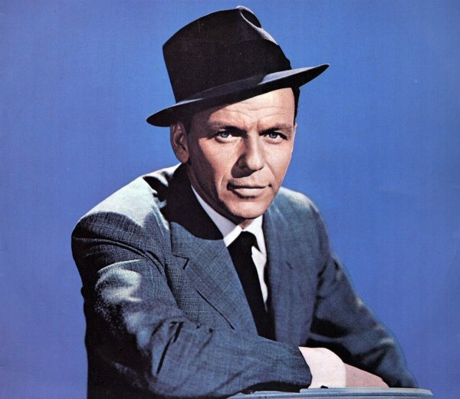 | 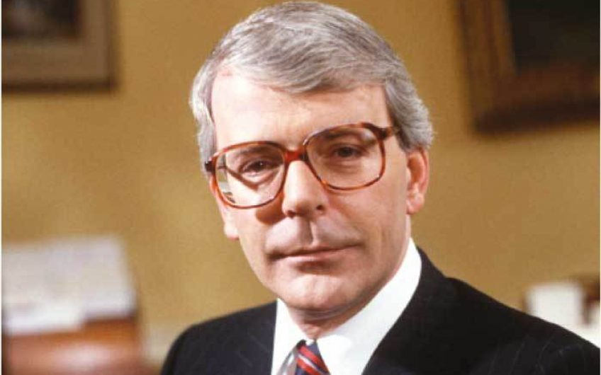  J
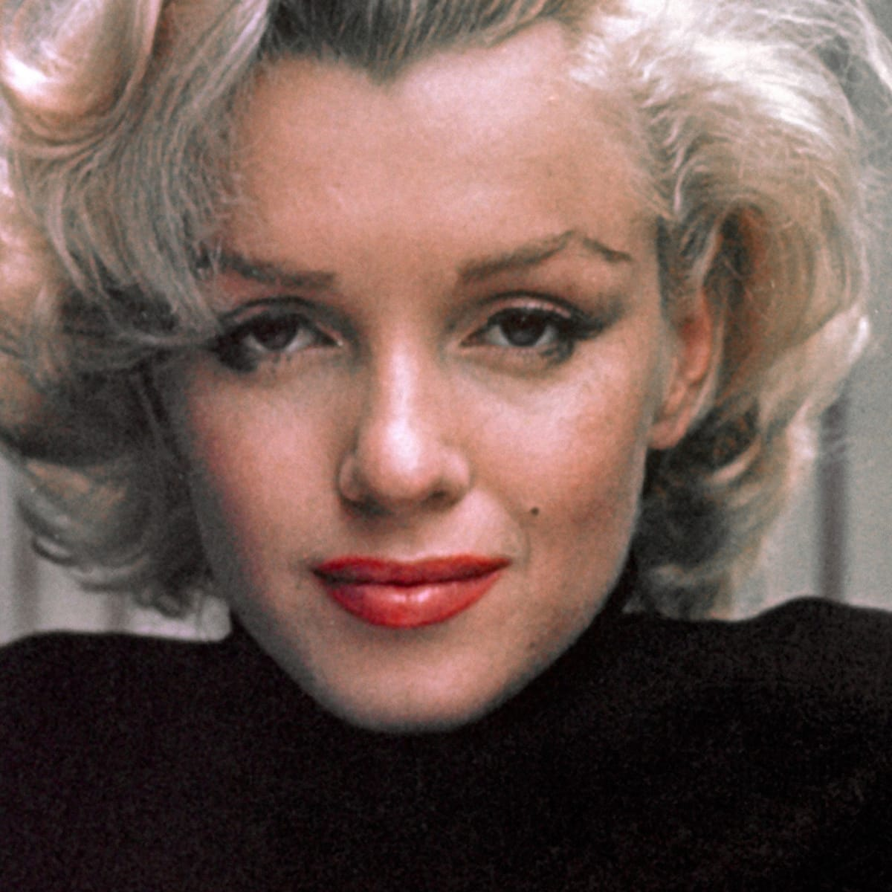  A |   B
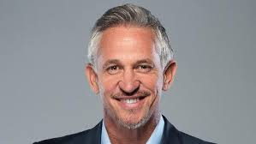  C |   D
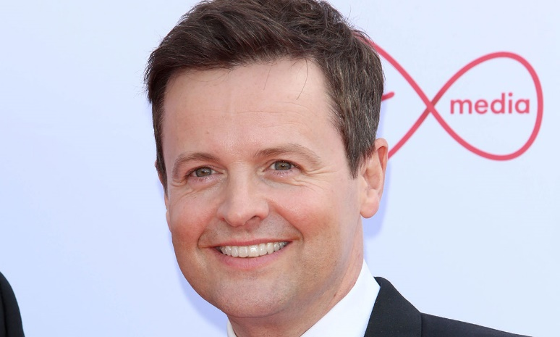  E | 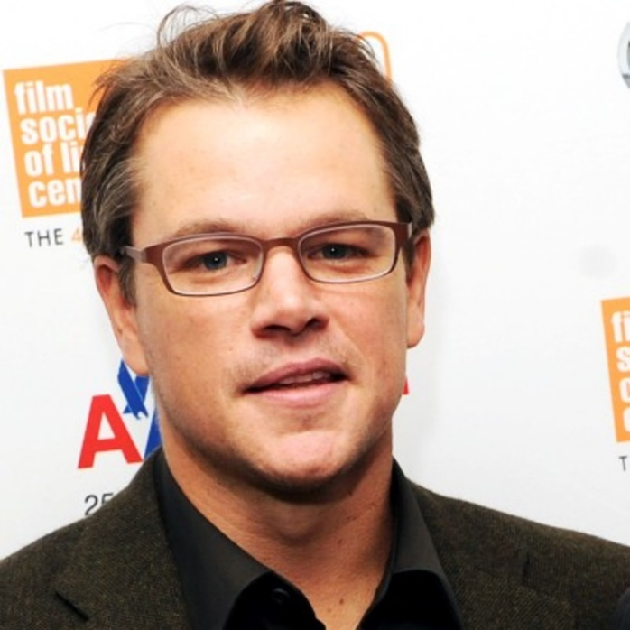  F

