Food & drink

- What meat is traditionally used in the Greek dish Kleftiko?

- Pink lady and granny smith are verieties of what fruit?

- What is the main ingredient in a Fu young?

- Queen Anne, Rainier, Montmorency and Morello are all varieties of what fruit?

- What country do burritos originate?

Music

- Who sang the songs China Girl, Space Oddity and Star Man?

- Complete these Adel lyrics “There’s a fire starting in my heart, reaching a fever pitch and it’s bringing me out the ……….”

- Heidi, Mutya, Amelle, Keisha, siobhan and Jade have all been singers in which British girl group?

- Highway to Hell and Back in Black are songs by which Australian rock band?

- Jenifer Hudson was discovered on which talent show?

Geography

- Machu Picchu is said to be one of the wonders of the world but what county is it in?

- The Arc de Trionph is in which capital city?

- What is the famous contemporary structure situated in Gateshead, it stands 20 metres tall, and is 54 metres across?

- In what county would you find the Eden project?

- In which country would you find the leaning tower of piesa?

History

- Robert Catesby, Thomas Winter, Thomas Percy, John Wright, and Guy Fawkes are famous for what historical event?

- Who was Henry the 8ths first wife?

- Emily Pankhurst was the leader of which movement during the 20th century?

- Who was UK prime minister in 2004?

- Who was the UK reigning monarch during ww2?

Film & TV

- Who was the leading actor in the green mile

- Who Directed the Titanic Movie starring Leonardo De Caprio and Kate Winslet?

- ‘There’s no place like home’ is a quote from what film?

- ‘Get busy living, or get busy dying.’ Is a quote from what 1994 American drama film directed by Frank Darabont?

- Who was the leading actor in the 1999 film ‘The Matrix’?

Science

- Who discovered penicillin?

- Cumulus, cirrus, stratus and nimbus are all types of what?

- What is the most common metal found on Earth?

- What is the Earth’s primary source of energy?

- Water is made up of what two elements?

Sports

- What do ice hockey players hit with their sticks to score?

- In football who has won the most gold and silver ball awards?

- Beth Twiddle is a name associated with which sport?

- Birdie and Bogey are terms associated with which sport?

- What sport would you be watching if you hat tickets for the Oval?

Picture
Answers
1 – Lamb, 2 – Apples, 3 - Egg, 4 – Cherries, 5 – Mexico, 6 – David Bowie, 7– Dark, 8 – SugarBabes, 9 – AC/DC, 10 – American Idol, 11– Paru, 12 – Paris, 13 – Angel of the north, 14 –Cornwall, 15 – Italy, 16 – the gunpowder plot, 17 – Catherine of Aragon, 18 – The Suffragettes, 19 –Tony Blair, 20 – George 6th, 21 – Tom Hanks, 22 – James Cameron, 23 – The Wizard of Oz, 24 – Shawshank redemption, 25 –Keanu Reeves, 26 –Alexander Fleming, 27 – Clouds, 28 –Iron, 29 The sun / solar, 30 - Hydrogen and oxygen, 31 – Puck, 32 Cristiano Ronaldo, 33 – Gymnastics, 34 – Golf, 35 – Cricket.

A – Kiwi, B – peach, C – Banana, D – Obergine, E – Potato, F – Cauliflower, G – apple, H – Pineapple, I - Carrot, J – Pomegranate

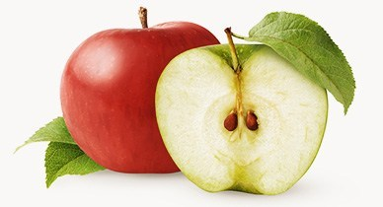  G | H  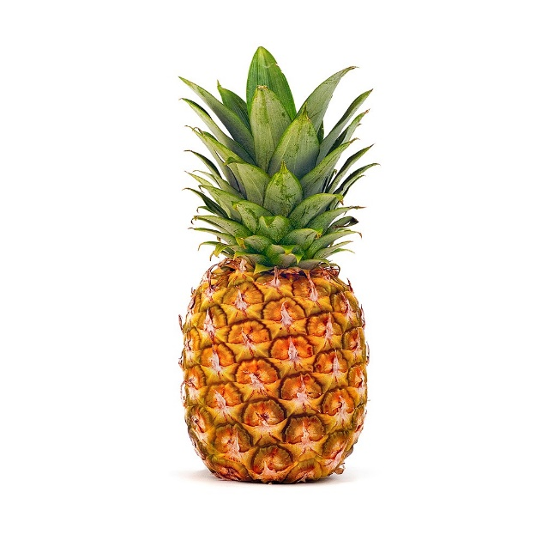
I   | 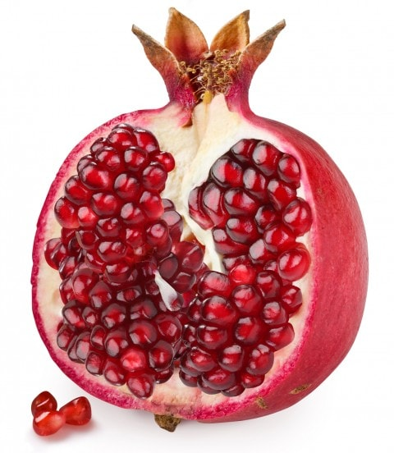  J
A  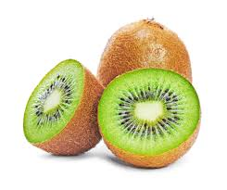 | 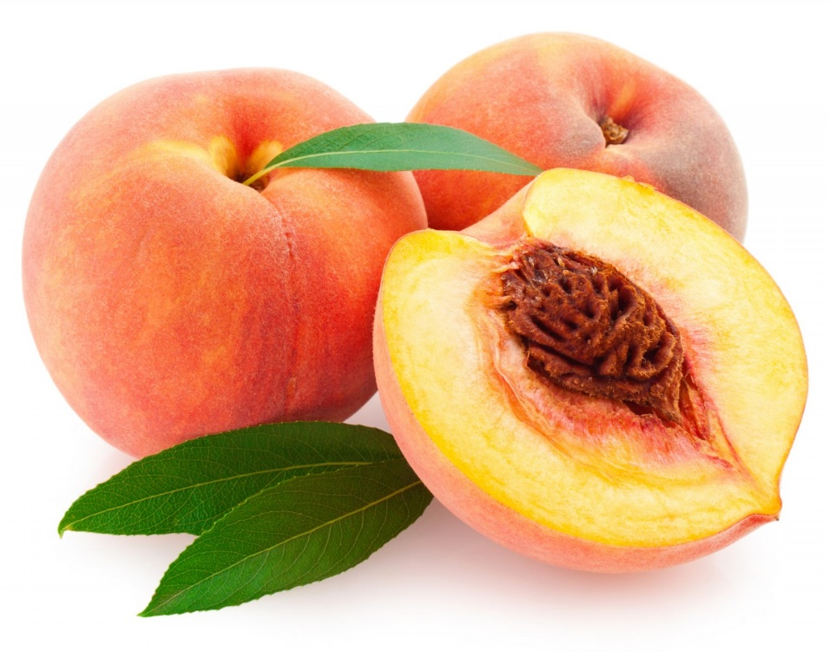  B
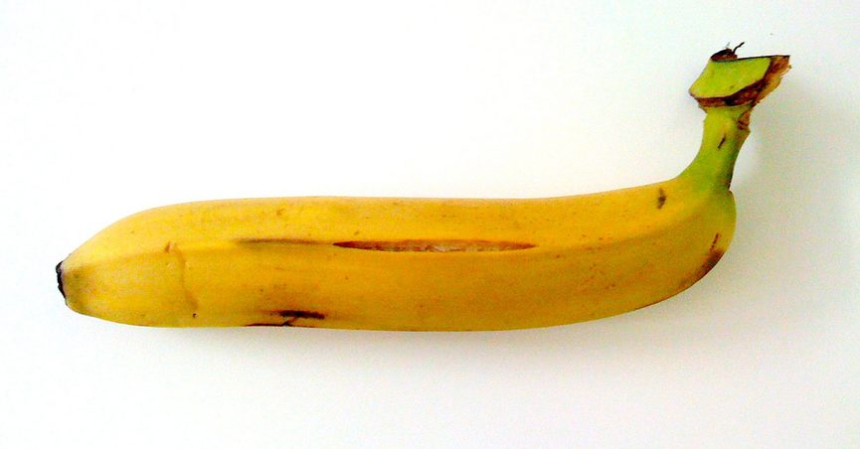  C | 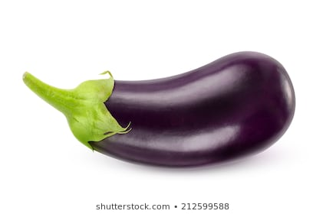  D
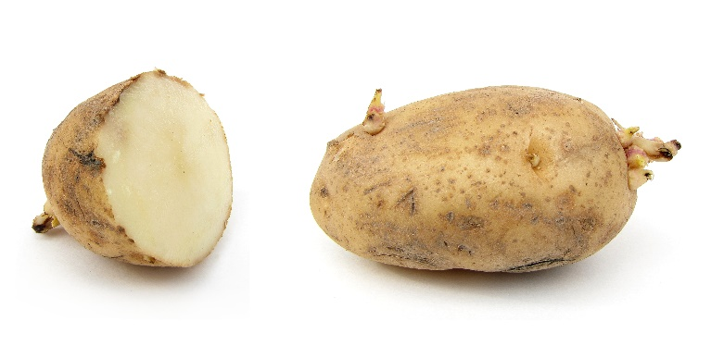  E | 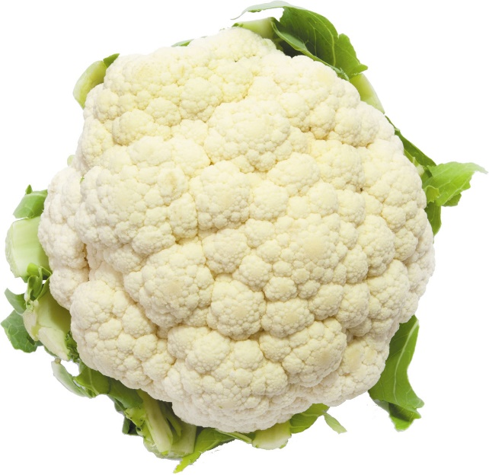  F

