Food & drink

- Calamari is a dish made with which animal?

- What Nut is traditionally used to make marzipan?

- Lactose is the sugars in which food group?

- Lamb is the meat of a baby sheep but what is the name of the meat of a baby Cow?

- Navel, Blood, Bergamot and Saville are all varieties of which fruit?

Music

- Which English Boy ‘Fell in love with a Galway Girl’?

- Which artist sang the songs ‘Is this Love’, ‘One Love’, ‘Could you be Loved’ and ‘No Woman no Cry’?

- What is the name of Eminem’s most famous alter ego?

- Rik Rok collaborated with which rapper to produce the hit song ‘It wasn’t me’?

- ‘Don’t go breaking my heart’, ‘your song’, ‘im still standing’ and ‘candle in the wind’ are all hits by whom?

Geography

- Which wonder of the world can you see from space?

- What is the horizontal line around the middle of the earth called?

- Which desert is almost the size of the USA and stretches across 10 countries?

- Mouna Loa, the largest active volcano in the world is in which country?

- Cairo is the capital of which country?

History

- Loop wholes, buttresses and turrets are features of what type of buildings?

- In WW2 the Dam busters were famous for destroying dams using what war time invention?

- Who was the reigning monarch of United Kingdom and Ireland from 1837 until 1901occupying the thrown for 63 years?

- How many wives did Henry the eighth have?

- Which ww2 plane had Rolls Royce Merlins or Griffons engins which made the planes super quick reaching its highest speeds of 606 miles per hour and used for close range combat with enemy planes?

Film

- Luke Hobbs, Brian O’Conner and Dominic Toretto are characters associated with which major film franchise?

- Who played Captain Jack Sparrow in the Pirates of the Caribbean Films?

- ‘Here’s Jonny’ is a famous line from which 1980 horror movie?

- Who was the director for the 1992 film ‘Reservoir Dogs’?

- Who played the leading man in the si-fi horror ‘I am legend’?

Science

- What is the chemical formula for water?

- The black dot in the human eye is known as the pupil but what is the colours part called?

- What is the human body’s biggest organ?

- Electric power is typically measured in what units?

- What is the first name of the famous scientist who gave us Newton’s three laws of motion?

Sports

- Alex "Hurricane" Higgins, Mark Williams, Steve Davis and Mark Selby are names associated with which sport?

- Who is known as the greatest golfer of all time?

- In which country is the Silverstone Race course?

- Which skating couple won gold in the 1984 winter Olympics with a never seen before perfect score?

- Which swimmer won the most gold medels of any sports in history of the Olympic games winning a total of 23 gold, 3 silver and 2 bronze?

Picture
  G | H  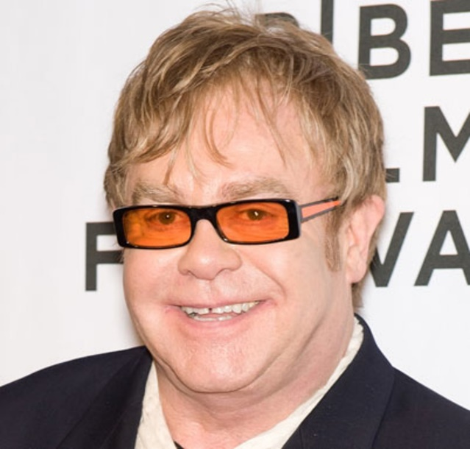
I   | 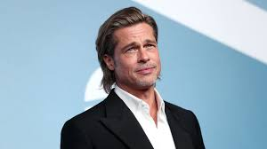  J
A  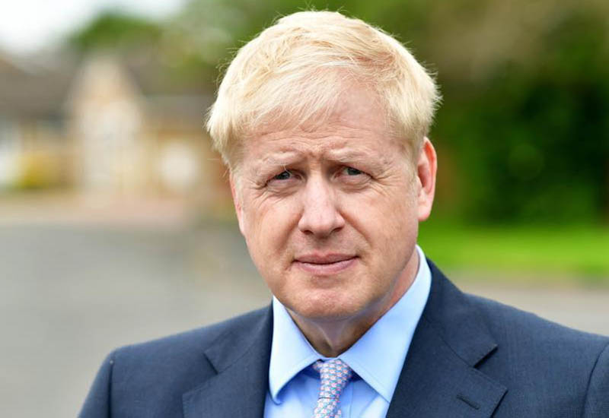 | 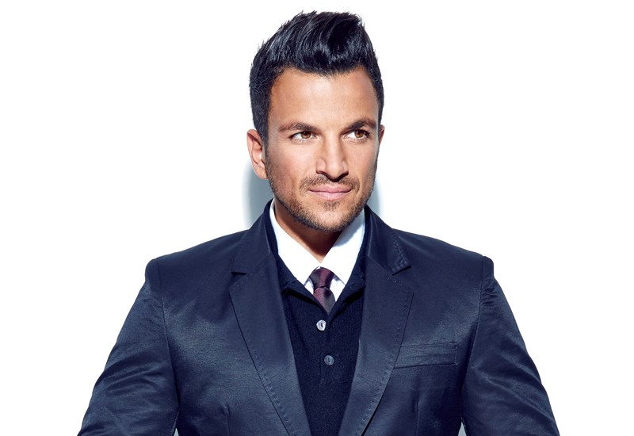  B
  C | 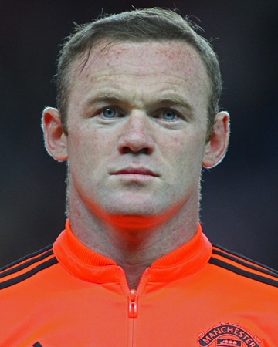  D
E   |   F

Answers
1 – Squid, 2 – Almond, 3 - Dairy, 4 – Veal, 5 – Orange, 6 – Ed Sheeran, 7–Bob Marley, 8 – Slim Shady 9 – Shaggy 10 – Elton John, 11–China wall, 12 – the equator, 13 – the Sahara, 14 –Hawaii 15 – Egypt 16 – Castles, 17 – the bouncing bomb, 18 – queen Victoria 19 – 6, 20 – spitfire, 21 – Fast and furious, 22 – Jonny Dept 23 – The Shining, 24 – Quentin Tarantino 25 – Will Smith, 26 –H2O 27 – Iris, 28 - Skin, 29 – Watts, 30 - Issac, 31 – snooker 32 – Tiger Woods, 33 – England, 34 – tovill and Dean, 35 – Michael Phelps

A – Borris Johnson, B – Peter Andre, C – Megan Markle, D – Wayne Rooney, E – Megan Fox, F – Donald Trump, G – Joe Essex, H – Elton John, I - Amy Winehouse, J – Brad Pitt

