[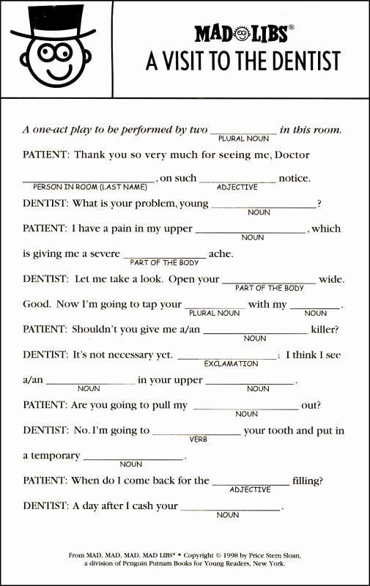](https://www.google.co.uk/url?sa=i&url=http%3A%2F%2Fsweetcupcakes.info%2Fprintable-mad-libs-for-adults-that-are-resource%2F&psig=AOvVaw2ptyyZF8D6w1GXYhlUUjkH&ust=1585317624420000&source=images&cd=vfe&ved=0CAIQjRxqFwoTCODIsMGmuOgCFQAAAAAdAAAAABBM)