[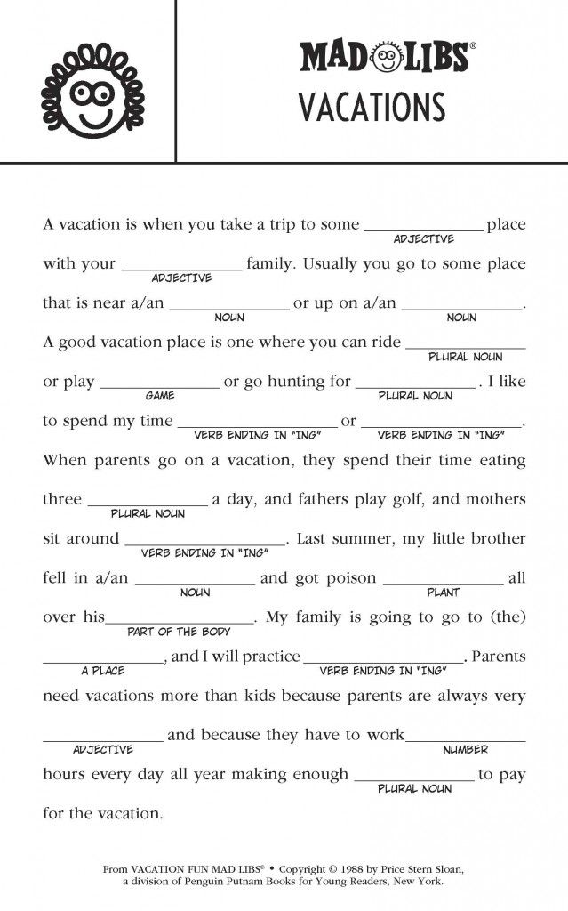](https://www.google.co.uk/url?sa=i&url=https%3A%2F%2Fwww.pinterest.com%2Fpin%2F444308319467319252%2F&psig=AOvVaw2ptyyZF8D6w1GXYhlUUjkH&ust=1585317624420000&source=images&cd=vfe&ved=0CAIQjRxqFwoTCODIsMGmuOgCFQAAAAAdAAAAABAE)