[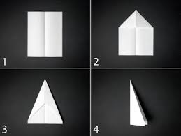](https://www.google.co.uk/url?sa=i&url=https%3A%2F%2Fwww.diynetwork.com%2Fmade-and-remade%2Flearn-it%2F5-basic-paper-airplanes&psig=AOvVaw1KdxE3aKoT83uxaP7yM3yB&ust=1588340047828000&source=images&cd=vfe&ved=0CAIQjRxqFwoTCNilkvWhkOkCFQAAAAAdAAAAABAD)

[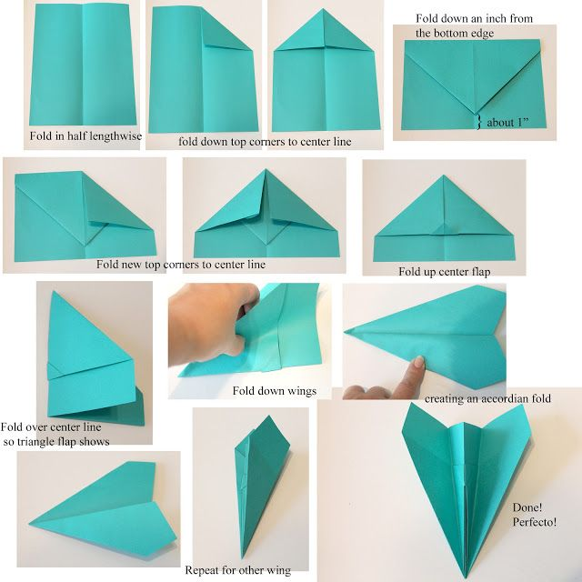](https://www.google.co.uk/url?sa=i&url=https%3A%2F%2Fwww.pinterest.com%2Fpin%2F443252788298412582%2F&psig=AOvVaw1KdxE3aKoT83uxaP7yM3yB&ust=1588340047828000&source=images&cd=vfe&ved=0CAIQjRxqFwoTCNilkvWhkOkCFQAAAAAdAAAAABAJ)

[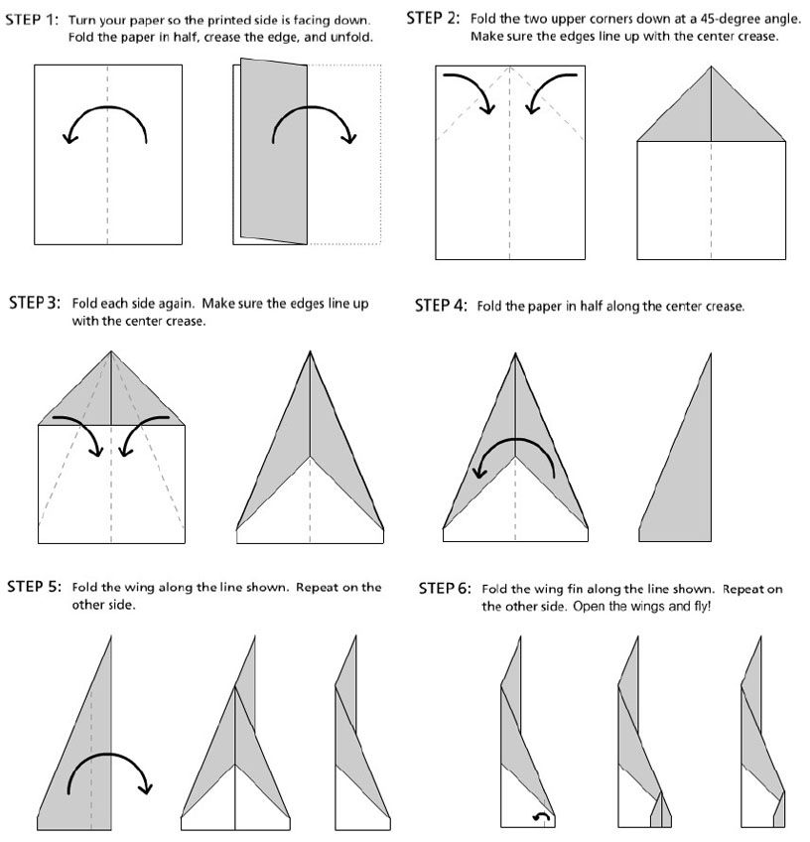](https://www.google.co.uk/url?sa=i&url=https%3A%2F%2Fwww.pinterest.com%2Fpin%2F173036810652902844%2F&psig=AOvVaw1KdxE3aKoT83uxaP7yM3yB&ust=1588340047828000&source=images&cd=vfe&ved=0CAIQjRxqFwoTCNilkvWhkOkCFQAAAAAdAAAAABAQ)

[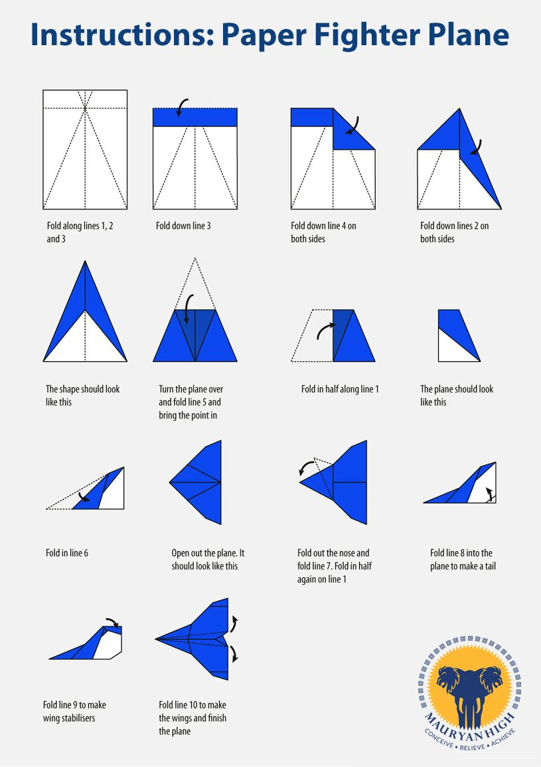](https://www.google.co.uk/url?sa=i&url=https%3A%2F%2Fin.pinterest.com%2Fpin%2F325666616796233338%2F&psig=AOvVaw1KdxE3aKoT83uxaP7yM3yB&ust=1588340047828000&source=images&cd=vfe&ved=0CAIQjRxqFwoTCNilkvWhkOkCFQAAAAAdAAAAABAl)