[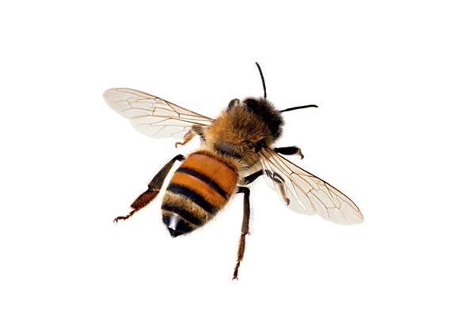](https://www.google.co.uk/url?sa=i&rct=j&q=&esrc=s&source=images&cd=&ved=2ahUKEwjPpOPYqNLjAhUc7eAKHfWODaUQjRx6BAgBEAU&url=https://www.terminix.com/blog/diy/how-to-tell-if-youre-allergic-to-a-bee-sting/&psig=AOvVaw2zY_be-KUCQAA4eb0jqMY5&ust=1564221312876205)[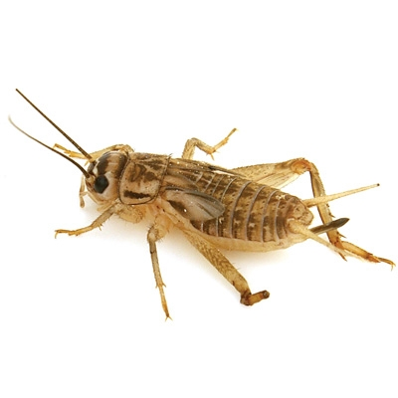](http://www.google.co.uk/url?sa=i&rct=j&q=&esrc=s&source=images&cd=&cad=rja&uact=8&ved=2ahUKEwifnprMqdLjAhUjDGMBHWkiAzoQjRx6BAgBEAU&url=/url?sa%3Di%26rct%3Dj%26q%3D%26esrc%3Ds%26source%3Dimages%26cd%3D%26ved%3D2ahUKEwi60_fJqdLjAhWo3OAKHXu9AFcQjRx6BAgBEAU%26url%3Dhttps://www.feedersource.com/product_p/crickets%20250.htm%26psig%3DAOvVaw3tR2qWBGmTO-e6CHGxNCMf%26ust%3D1564221542571821&psig=AOvVaw3tR2qWBGmTO-e6CHGxNCMf&ust=1564221542571821)[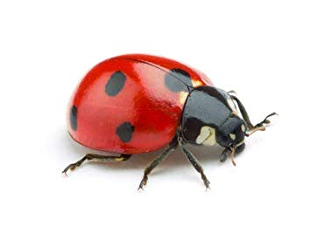](https://www.google.co.uk/url?sa=i&rct=j&q=&esrc=s&source=images&cd=&ved=2ahUKEwj76vrvp9LjAhWSEBQKHX-9Bg8QjRx6BAgBEAU&url=https://www.amazon.co.uk/Dragonfli-Ladybird-Adults-Ladybirds-Greenfly/dp/B07CGKKJK8&psig=AOvVaw3Hs3S6870PnmxND48TfDwM&ust=1564221109179058)

[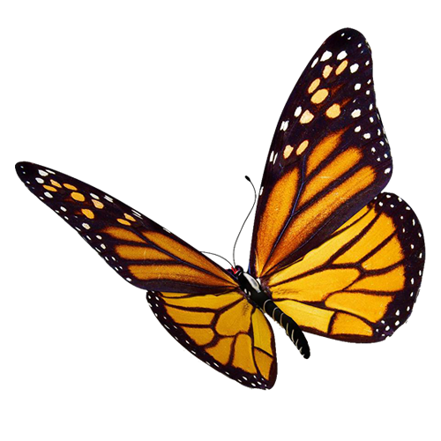](https://www.google.co.uk/url?sa=i&rct=j&q=&esrc=s&source=images&cd=&ved=2ahUKEwjT5NuvqNLjAhXZ8OAKHd64Dg4QjRx6BAgBEAU&url=https://sciencebob.com/what-is-the-difference-between-a-moth-and-a-butterfly/&psig=AOvVaw2w3apcQRNuvu7b0aX-j9ZD&ust=1564221241259269)

**Questions**

1. **Where do these creatures live?**
2. **What type of animal are these?**
3. **Which one is an odd one out?**
4. **Can you name all four?**
5. **Fun Fact . . . .**  The number of insect species is believed to be between six and ten million.

**Categorisation activity – good for concept formation and processing skills**

Create a large board and divide into three sections.

Title the sections – insects that sting, anthropods, beetles – depending on how knowledgeable your patient is

Then you, the patient and potentially member of nursing staff try and categorise the pictures, sticking each one in turn to the board.

This generates a lot of discussion about the similarities and differences