[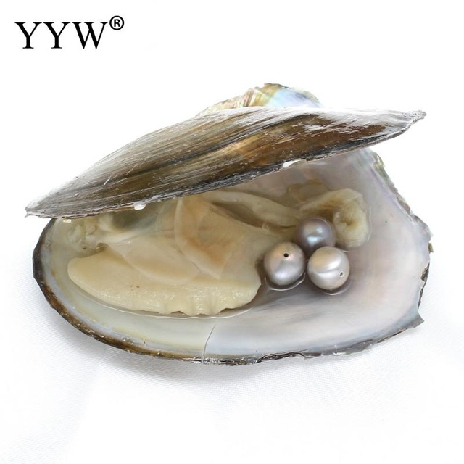](http://www.google.co.uk/url?sa=i&rct=j&q=&esrc=s&source=images&cd=&cad=rja&uact=8&ved=2ahUKEwjI-YW9p9LjAhWL3OAKHdsLBrQQjRx6BAgBEAU&url=/url?sa%3Di%26rct%3Dj%26q%3D%26esrc%3Ds%26source%3Dimages%26cd%3D%26ved%3D2ahUKEwjI-YW9p9LjAhWL3OAKHdsLBrQQjRx6BAgBEAU%26url%3Dhttps://www.aliexpress.com/item/YYW-Vacuum-packed-Freshwater-Cultured-Love-Wish-Pearl-Oyster-Gifts-3pcs-7-8mm-Potato-Beads-inside/32817813182.html%26psig%3DAOvVaw13B3fH4TV2gHtehSwYHA3Z%26ust%3D1564220978892555&psig=AOvVaw13B3fH4TV2gHtehSwYHA3Z&ust=1564220978892555)[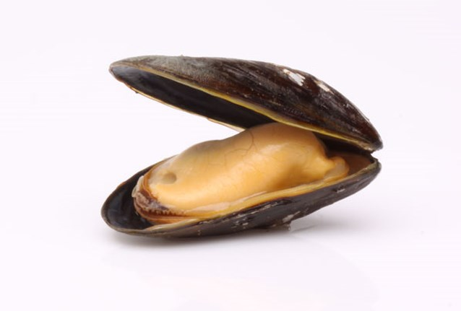](http://www.google.co.uk/url?sa=i&rct=j&q=&esrc=s&source=images&cd=&cad=rja&uact=8&ved=2ahUKEwizsL6Hp9LjAhWuDmMBHe31ApwQjRx6BAgBEAU&url=/url?sa%3Di%26rct%3Dj%26q%3D%26esrc%3Ds%26source%3Dimages%26cd%3D%26ved%3D2ahUKEwizsL6Hp9LjAhWuDmMBHe31ApwQjRx6BAgBEAU%26url%3Dhttps://www.nieuwsblad.be/cnt/dmf20120704_076%26psig%3DAOvVaw2PEkA5vj7w8gAvsDlGAUt_%26ust%3D1564220872399108&psig=AOvVaw2PEkA5vj7w8gAvsDlGAUt_&ust=1564220872399108)[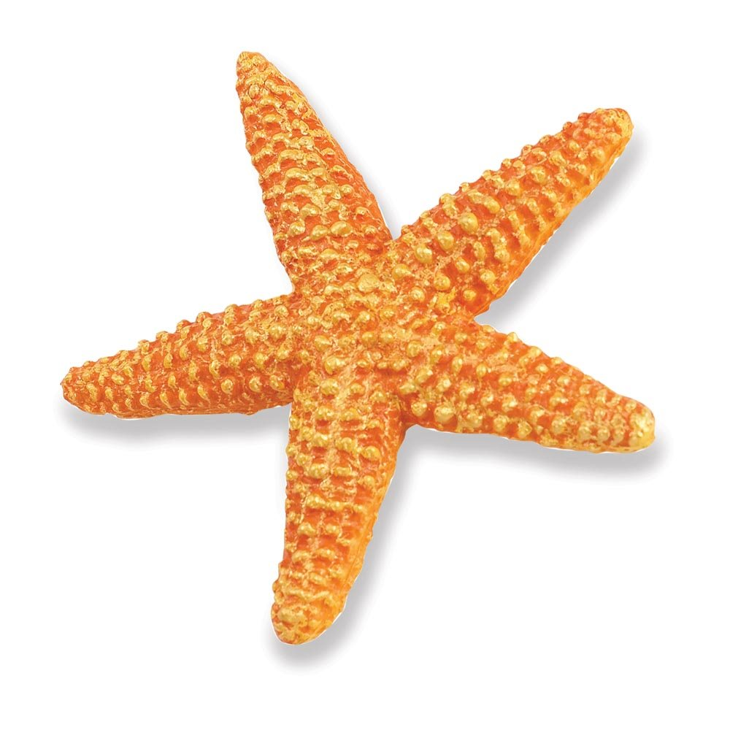](http://www.google.co.uk/url?sa=i&rct=j&q=&esrc=s&source=images&cd=&ved=2ahUKEwj14PvPptLjAhWpDmMBHSeKBkIQjRx6BAgBEAU&url=http://www.dinosaurtime.co.uk/products/safari-ltd-orange-starfish.html&psig=AOvVaw0CQuIpswZg4v6Ip2X4Qw_C&ust=1564220774665831)

[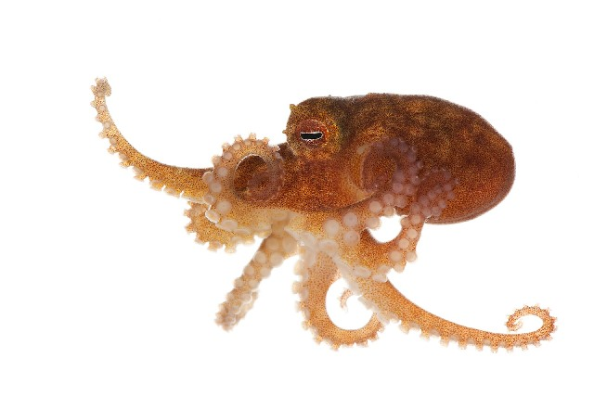](http://www.google.co.uk/url?sa=i&rct=j&q=&esrc=s&source=images&cd=&cad=rja&uact=8&ved=2ahUKEwiw6tezptLjAhVHBGMBHTu2B0MQjRx6BAgBEAU&url=http://v3.boldsystems.org/index.php/Taxbrowser_Taxonpage?taxid%3D4430&psig=AOvVaw0a3P4nkhN5LRsjjf4A16Ip&ust=1564220691679555)

**Questions**

1. **Where do these creatures live?**
2. **What type of animal are these?**
3. **Which one is an odd one out?**
4. **Can you name all four?**
5. **Fun Fact . . .** *Octopuses have nine brains, three hearts and blue blood.*

**Categorisation activity – good for concept formation and processing skills**

Create a large board and divide into three sections.

Title the sections – crustaceans, molluscs and fish (Or alternative if you know of other categories)

Then you, the patient and potentially member of nursing staff try and categorise the pictures, sticking each one in turn to the board.

This generates a lot of discussion about the similarities and differences

*Is a star fish a fish?*