[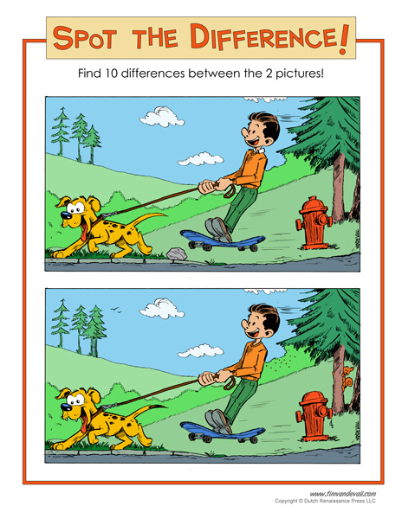](https://www.google.co.uk/url?sa=i&url=https%3A%2F%2Fwww.timvandevall.com%2Factivities%2Fspot-the-difference-printable%2F&psig=AOvVaw3vC4M9kvhTe07go3jB7SwO&ust=1585314596933000&source=images&cd=vfe&ved=0CAIQjRxqFwoTCIj8tZ2buOgCFQAAAAAdAAAAABAj)